**Shell script for log into aws console by using Programmatic access:**

* Create the ec2 instance and while creating ec2 instance attach the IAM role to access the s3 service.
* This is the shell script for creating list the buckets and check the memory space ,cpu,process.

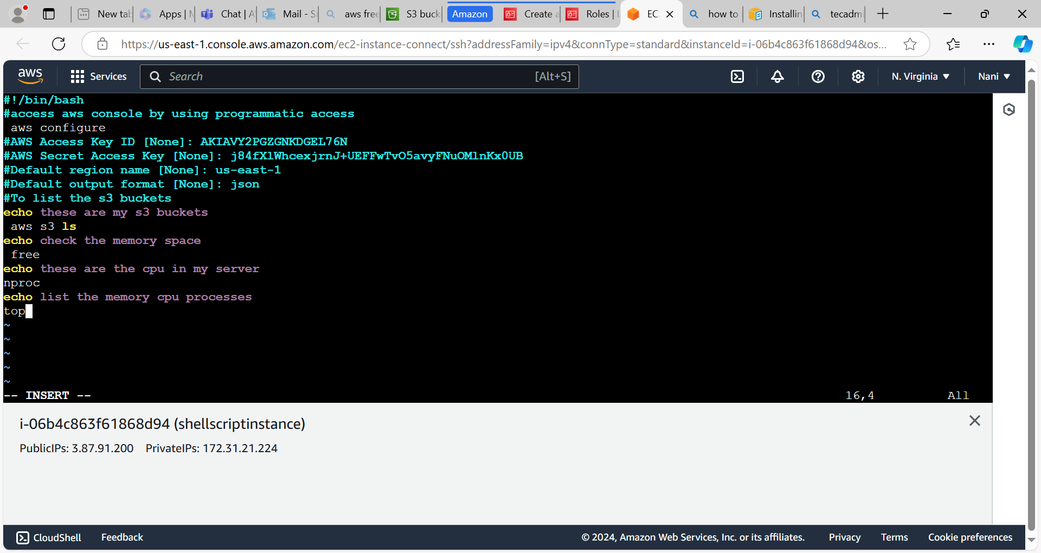

After executing shells script

